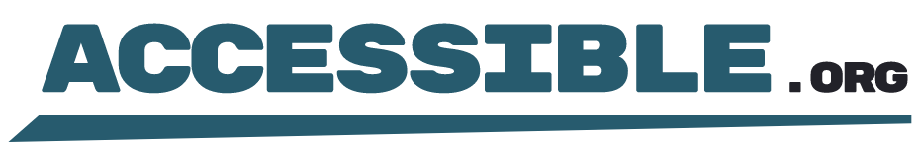

Statement of Conformance
Date of Issuance: July 7, 2024
This document hereby states that Website.com, for the defined scope, is in full conformance with the Web Content Accessibility Guidelines (WCAG) version and conformance level as stated herein.

Version
Web Content Accessibility Guidelines Version 2.1

Level
Conformance Level: AA

Date
Date of Conformance Claim: July 1, 2024

Scope
Scope of Conformance: The following URLs and all content contained therein are in full conformance:
Category: https://website.com/category
Product: https://website.com/product-1
Blog: https://website.com/blog
Info: https://website.com/info
Contact us: https://website.com/contact-us
FAQs: https://website.com/faq
Returns: https://website.com/returns
Shipping: https://website.com/shipping
Support: https://website.com/support
Privacy Policy: https://website.com/privacy-policy

Issuer
Accessible.org

