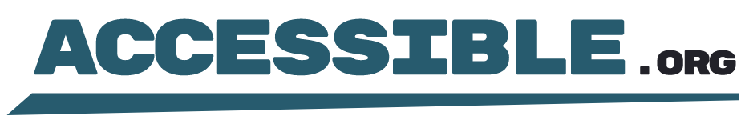

Digital Accessibility Certification
Date of Issuance: May 1, 2025
Document Issued to: [Client Name]
This document hereby certifies that the named digital asset, for the defined scope, fully conforms with the Web Content Accessibility Guidelines (WCAG) version 2.1 conformance level AA on May 1, 2025.
Digital Asset:
[Digital Asset Name]

Evaluation Methodologies
The named digital asset has been formally evaluated using the following methodologies:
- Screen reader testing
- Keyboard testing
- Visual inspection
- Code inspection
- Automated scan

Environments
The named digital asset has been formally evaluated using the following environments:
- Windows 10
- Chrome Browser
- NVDA screen reader
- iOS 15
- Safari Browser
- VoiceOver screen reader

Findings
After extensive evaluation and validation, https://gatortec.com, for the defined scope, was found to have 0 accessibility issues for both desktop and mobile environments per WCAG 2.1 AA.

Scope
The scope of evaluation includes content, components, functions, pages, and screens located at:
- [Scope]

Verification
For verification of this certification's authenticity, contact:
Email: certification@accessible.org
Include the URL and date of certification in your verification request. Verification requests will receive a response within 1-3 business days.
Accessible.org will confirm and verify the issuance of this certification for a period of one (1) year from the date of issuance. After this date, the certificate holder will need to have the digital asset re-audited to be eligible for newly issued certification and verification. This verification limitation does not change the fact that any modifications to the digital asset immediately affect the certification's applicability, as detailed in the Future Changes Disclaimer.

Future Changes Disclaimer
This certification applies only to the digital asset as evaluated on May 1, 2025. Any subsequent changes, updates, modifications, or additions to the website (including content, design, functionality, or structure) made after the date of evaluation are not covered by this certification.

Document Issuer
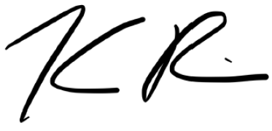
Kris Rivenburgh
Founder
Accessible.org, LLC
